EXPERIMENT 33
Create a Rectangle on a White Image Using OpenCV
Aim:
To create a white image of user-defined size and draw a rectangle using OpenCV.
Procedure:
- Import OpenCV and NumPy.
- Get image height and width from the user.
- Create a white image.
- Draw a rectangle using cv2.rectangle().
- Display the output image.
Program:
import cv2
import numpy as np

h = int(input("Enter height: "))
w = int(input("Enter width: "))

img = np.ones((h,w,3), dtype=np.uint8) * 255

cv2.rectangle(img, (50,50), (w-50,h-50),
(0,0,255), 3)

cv2.imshow('Rectangle', img)

cv2.waitKey(0)
cv2.destroyAllWindows()

Input:

Output:
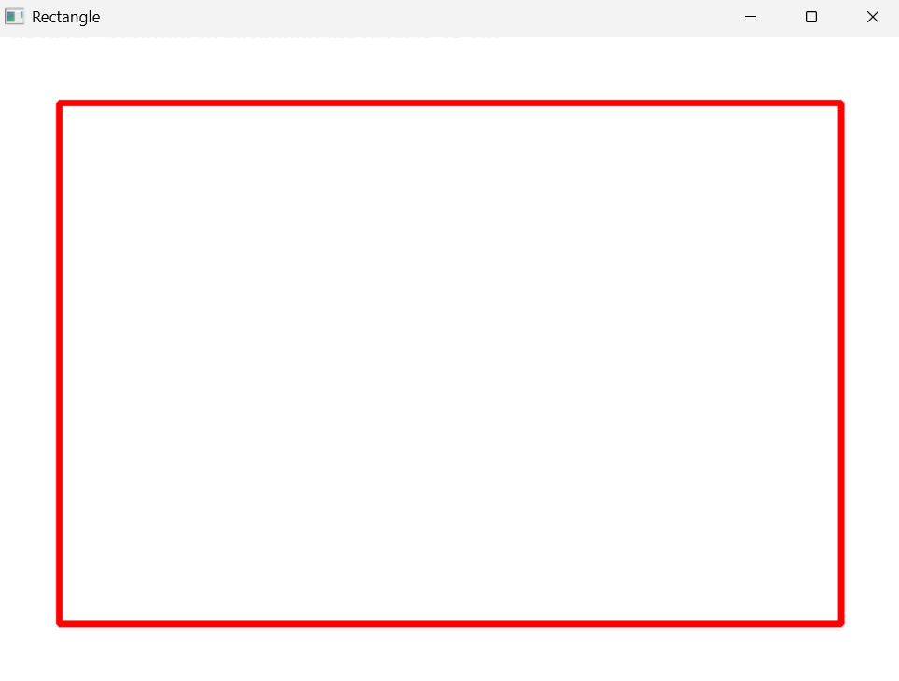
Result:
Thus, a rectangle was successfully created on a white image using OpenCV.

